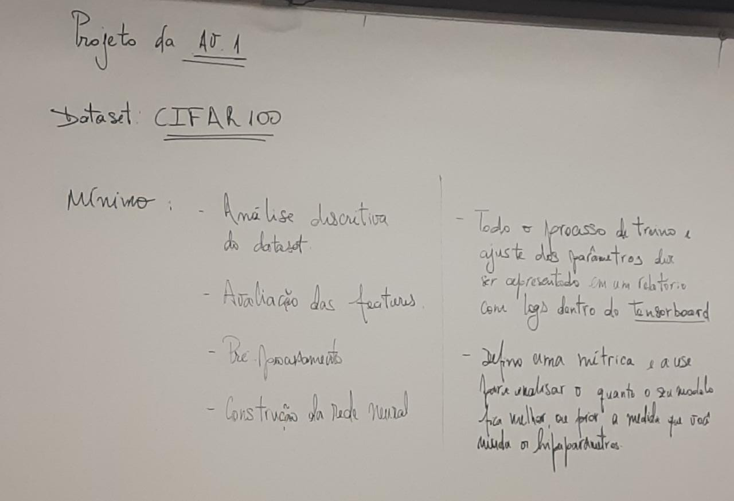

* <https://www.kaggle.com/flaviagg/projeto-av1-de-deep-learning/edit> ;
* <https://colab.research.google.com/drive/1yiK86zdlmszPEDDzysxDbL34Z0yuJ9DL?authuser=1> ;
* <https://medium.com/ensina-ai/redes-neurais-com-tensorflow-primeiros-passos-20847dd5d27f> ;
* <https://towardsdatascience.com/cifar-100-pre-processing-for-image-recognition-task-68015b43d658> ;
* <https://www.codigofluente.com.br/aula-24-tensor-flow-keras-conjunto-de-dados-cifar-10/> ;
* <https://lamfo-unb.github.io/2020/10/26/CNN/> ;
* <https://colab.research.google.com/drive/19ahrYMDcbONGt5tnePnjOXQOObpZIija?usp=sharing> ;